We have done these 4 Analytical methods to gain some Insights from the cleaned dataset that we are having.

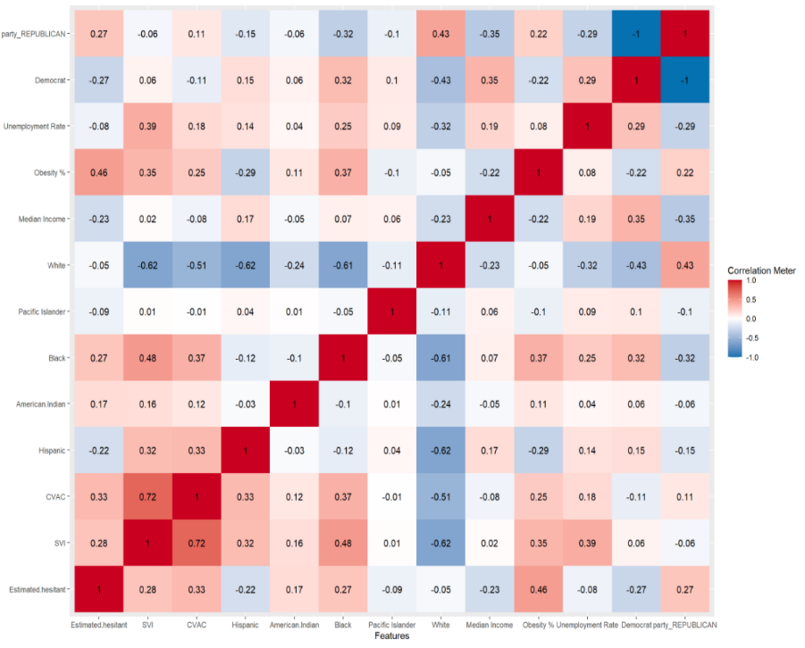As a team, the exploration process was started with this simple descriptive statistic method of correlation, just to understand the strength of relationship between Multiple variables which are present in the dataset.

* In the Plot the Red represents the Positive Correlation and the Blue shows negative correlation.
* The Contrast was adjusted to the colours in a way, so that if there is a strong correlation then the contrast will be High, if there is a weak correlation then the contrast will be less.
* The Very First column which is labelled as Estimated Hesitant, is the dependent Variable, Remaining Variables that can be noticed are some of the other numeric Variables that are present in our Dataset.

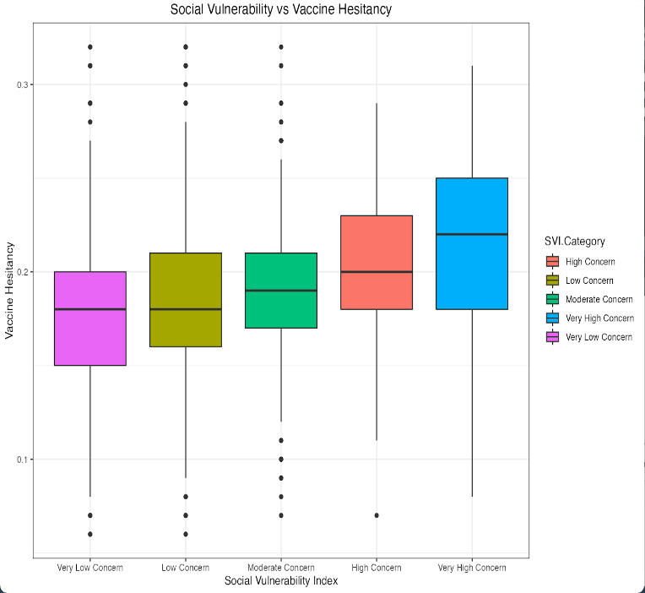

* As a Second step in the process, wanted to check “Is SVI Category index directly related to Vaccine Hesitancy?”
* From the Boxplot, it can be clearly noticed that as the level of concern Increases, Vaccine Hesitancy appears to Increase.

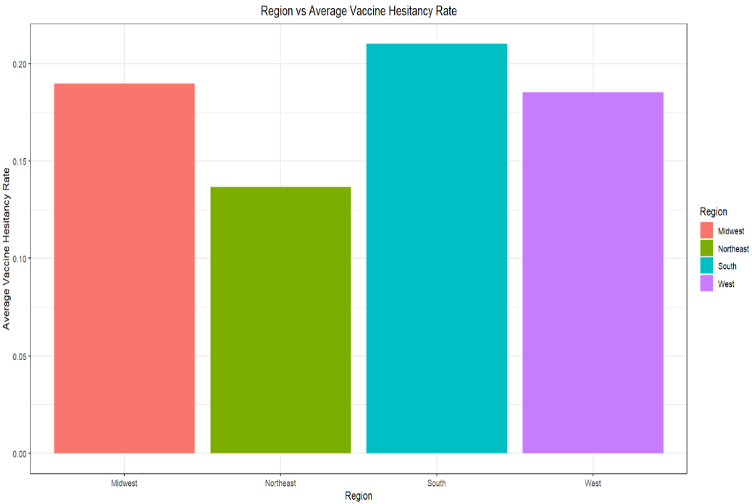

In the process of exploring another categorical variable “What is the Region with Highest Vaccine Hesitancy Rate? “

* For this, An Average was taken for estimated Hesitancy rate by grouping counties based on Region.
* South Region has the Highest VH rate, followed by Midwest, west and Northeast.

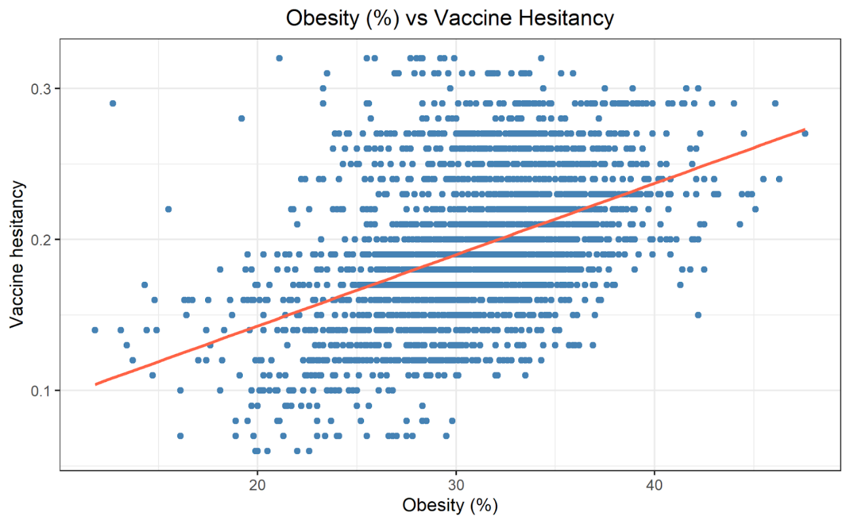

This is the Interesting Part as this Variable has the Highest correlation value of 0.46 with our Dependent Variable of Vaccine Hesitancy.

A trend has been noticed as “As the VH rate is High in the Counties where Obesity Rate is High”.

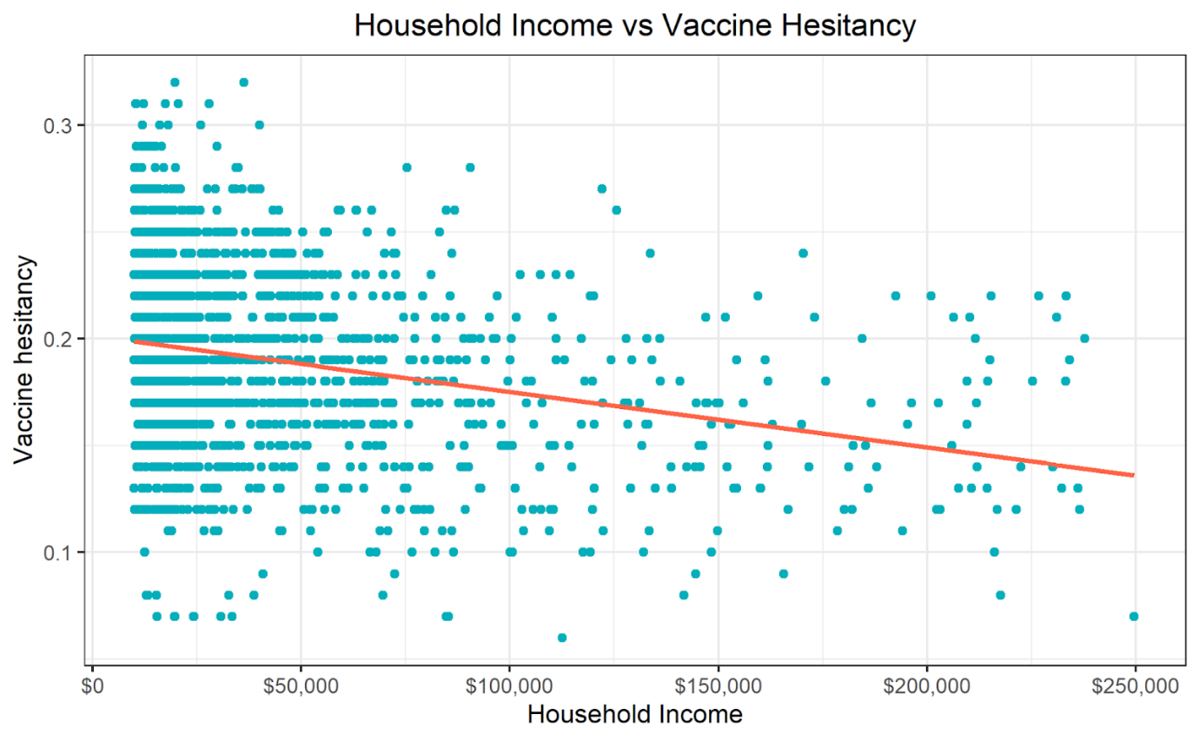 As a next step in the exploration process, the findings were “Vaccine Hesitancy is High when the Median Household Income is less than 50,000$” & the Trend is “As Median HH Increases the VH rate appears to be decreasing”. Both the Variables are negatively correlated with a value of 0.23.

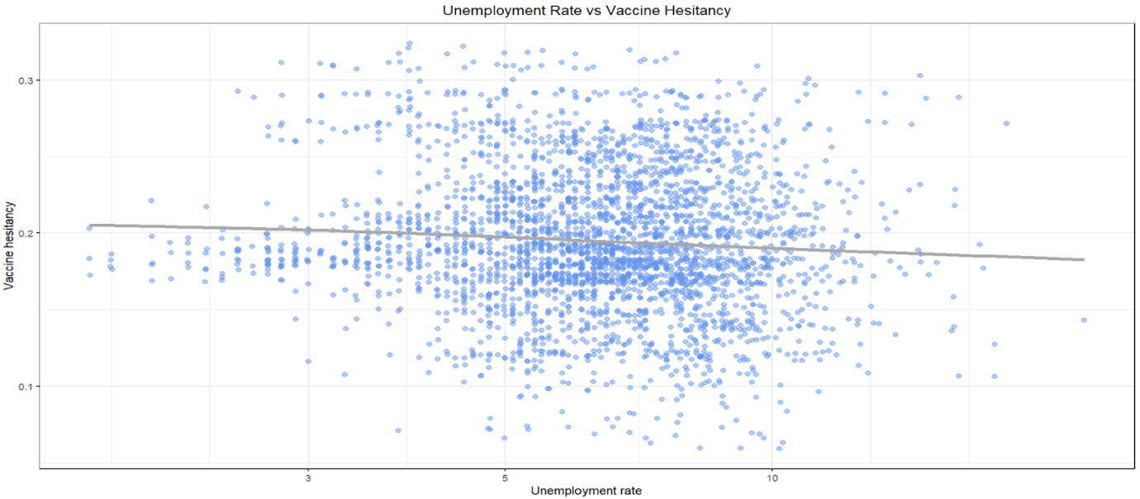

The Unemployment rate and Vaccine Hesitancy variables have a weak negative correlation. From the above scatterplot, it can be noticed that the trend is “where the Unemployment Rate is High, there is 8 % less vaccine hesitancy”.

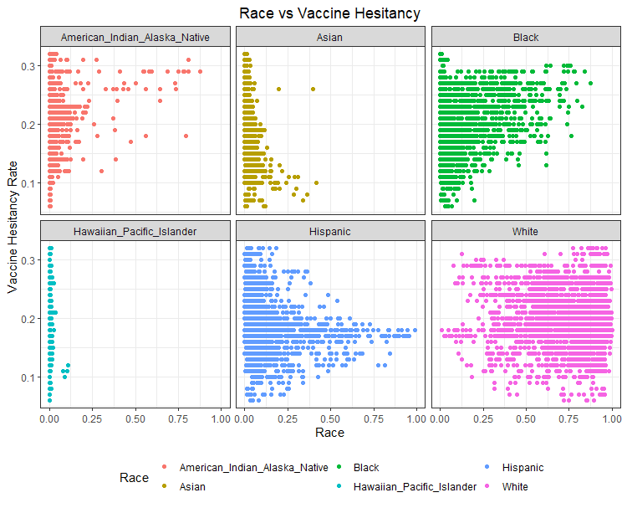

For this x is percentage of people, y is Vaccine Hesitancy Rate, Facet has been arranged based on different race.

By Using above facet wrap graph, Vaccine Hesitancy as per Race has been Explored.

#Not Sure how to exactly Infer.( Need to Discuss)

As per the Findings the Trend is as follows

* “American Natives have a positive correlation and Asians have negative Correlation.”
* “ Counties where the Percent of Whites are More,

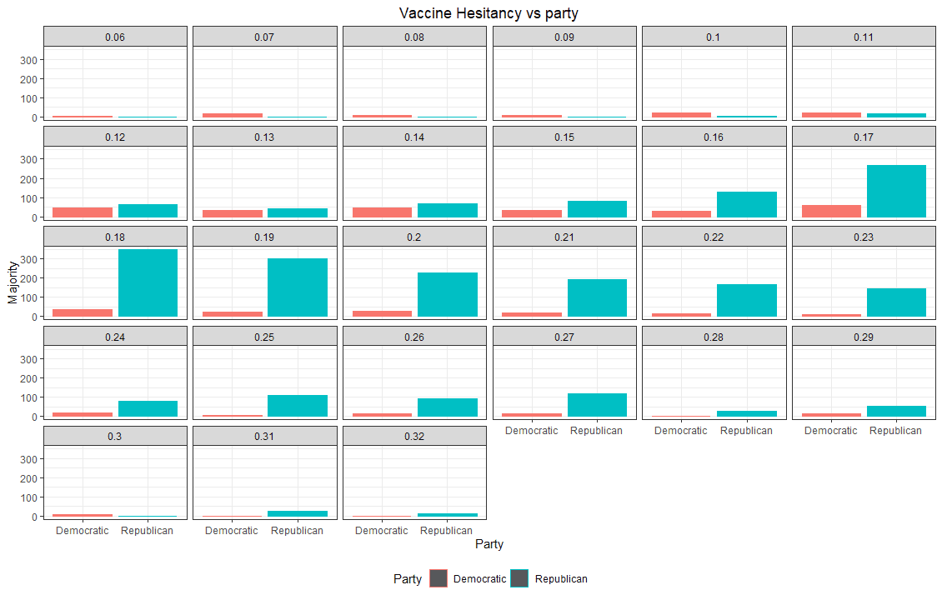

X is the Party, y is the Number of counties, Red- Democratic, Blue - Republic

Republic + 0.27, Democrat – (-0.27)

While exploring the dataset we also wanted to check the Hesitancy rate wrt Political Affiliation,

the Red Represents the Democratic party and Blue represents Republic Party Majority.

Based on this we were able to see that as the Estimated Hesitancy is positively correlated with the Counties where Republic Party has Majority and Negatively Correlated with the Democratic Party.